# Italy – Script Instruction

**Official URL:** <https://www.gazzettaufficiale.it/30giorni/serie_generale>

Start by going to the [Ricerca Avanzata (Advanced Search)](https://www.gazzettaufficiale.it/ricerca/atto/serie_generale/originario?reset=true&normativi=true) feature.

Please use only the Parole nel titolo (Words in the title) function, selecting la seguente frase (the following sentence), and enter the Italian keywords from the list of keywords into the text field to retrieve matches. Insertion of quotation marks around the keywords is no longer necessary (e.g., pari opportunita).

After entering the keywords, hit ENTER from the keyboard as the button Cerca (Near) is not working on the site.

## Extraction of Metadata

The results page only displays the legislation titles. 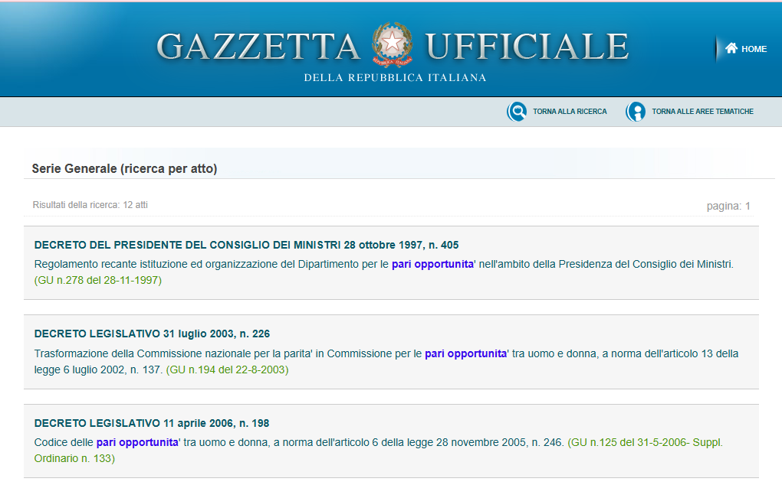

Please open each piece of legislation to extract the full metadata. When already on the legislation page, extract the full metadata indicated by color boxes in the screenshot (below) after the bullet items as follows.

* Source link – the URL of the legislation document.
* Original title – the complete title displayed on the page, labeled in red.
* Type of regulation – publicly available from the title, labeled in green
* Date of adoption – publicly available from the title, labeled in blue.
* Entry into force date – look for the term “in vigore” (into force) in the “Note” section, labeled in purple.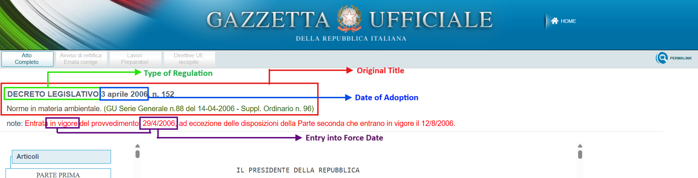

## Additional notes in extracting the metadata

**Original Title** - Please combine the short title and the long title, separated by a dash, to form the complete title. For example: [DECRETO LEGISLATIVO 3 aprile 2006, n. 152](https://www.gazzettaufficiale.it/atto/serie_generale/caricaDettaglioAtto/originario?atto.dataPubblicazioneGazzetta=2006-04-14&atto.codiceRedazionale=006G0171)

  
Complete Title:  
DECRETO LEGISLATIVO 3 aprile 2006, n. 152 - Norme in materia ambientale. (GU Serie Generale n.88 del 14-04-2006 - Suppl. Ordinario n. 96)

[For Ashan: We are still confirming this title structure to the client. So please leave this for the time being until we receive client’s confirmation.]

[17-June - For Ashan: This is now confirmed. Please proceed with this structure.]

**Type of Regulation** – It primarily appears in the main title. Please use the English term in the scraped output.

1. Legge (Law)
2. Decreto (Decree) – It has other legislative terms, but they still fall under Decree. Please ensure that you capture “Decree” in the output.
   * Decreto-Legge (Decree-Law)
   * Regio Decreto (Royal Decree)
   * Regio Decreto-Legge (Royal Decree-Law)
   * Decreto Legislativo (Legislative Decree)
   * Decreto del Presidente (Presidential Decree)

**Date of Adoption** – the date format on the source website is “dd mmm yyyy”. Please convert it to yyyy-mm-dd in the output.

**Entry into Force Date** – the date format on the source website is in “dd-mm-yyyy”. Please convert it to yyyy-mm-dd in the output.

## Important Reminders

1. Duplicate titles and/or source links should be removed and retain one copy of each duplicate.
2. Follow this date format for consistency – yyyy-mm-dd.
3. For non-English, please translate all the type of regulation column into English:

* Legge (Law)
* Decreto (Decree)

1. Add one column beside the Original Title and translate the titles into English.
2. Please exclude any legislations containing the following Italian terms in the Complete Title:

* modifiche (amendments)
* appropriazione (appropriation)
* bilancio (budget)
* abrogato (repealed)
* revocato (revoked)
* aeroporto (airport)
* compagnia aerea (airline)
* appuntamento (appointment)
* nominato (appointed)
* paziente (patient)
* coronavirus / COVID-19